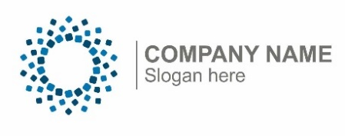
Insert company logo

Contact Name
Contact Title
Name of Organization
Contact email address and phone number

For Immediate Release

ORGANIZATION NAME receives grant to fuel local solutions to early childhood care and education challenges

More than $2.1 million in grant funding has been awarded to fuel 59 All in for Kansas Kids Quality Subgrants.
ORGANIZATION NAME was among those that received a grant. NAME received $ to BRIEF DESCRIPTION OF WHAT THE GRANT WILL FUND.
ADD QUOTE HERE FROM STAFF PERSON COMMENTING ON HOW EXCITED THEY ARE TO RECEIVE THE FUNDS AND HOW THOSE FUNDS WILL BE PUT TO USE TO SERVE CHILDREN, FAMILIES AND THEIR COMMUNITY.
Grantees from organizations and child care providers large and small from all across the state will use their awards to develop and implement new approaches that help children and families in their communities thrive. More than 140 applications were submitted, each focusing on addressing gaps in access, availability, and quality of child care, as well as community-level supports for families. The work is addressing gaps identified in the 2019 Needs Assessment and is being guided by the All in for Kansas Kids Strategic Plan, which maps the state’s future direction for early childhood.
To learn more about specific funded programs and activities, and to connect with the All in for Kansas Kids Strategic Planning efforts to strengthen the Kansas early childhood care and education system, please visit the Kansas Children’s Cabinet and Trust Fund website at http://AllinforKansasKids.org.
Funds for All In For Kansas Kids activities are partially provided through the Department of Health and Human Services (HHS), Administration for Children and Families (ACF) Every Student Succeeds Act (ESSA). The Preschool Development Grant Birth through Five Renewal 90TP0078-01-00 ($8,943,000) was awarded to the Kansas Children’s Cabinet and Trust Fund. The Kansas State Department of Education, the Kansas Department for Children and Families, and the Kansas Department of Health and Environment are leading this work with the Children’s Cabinet. This information or content and conclusions should not be construed as the official position or policy of, nor should any endorsements be inferred by, HHS, ACF, or the U.S. Government. Any food or refreshments are not paid for by federal funds.

