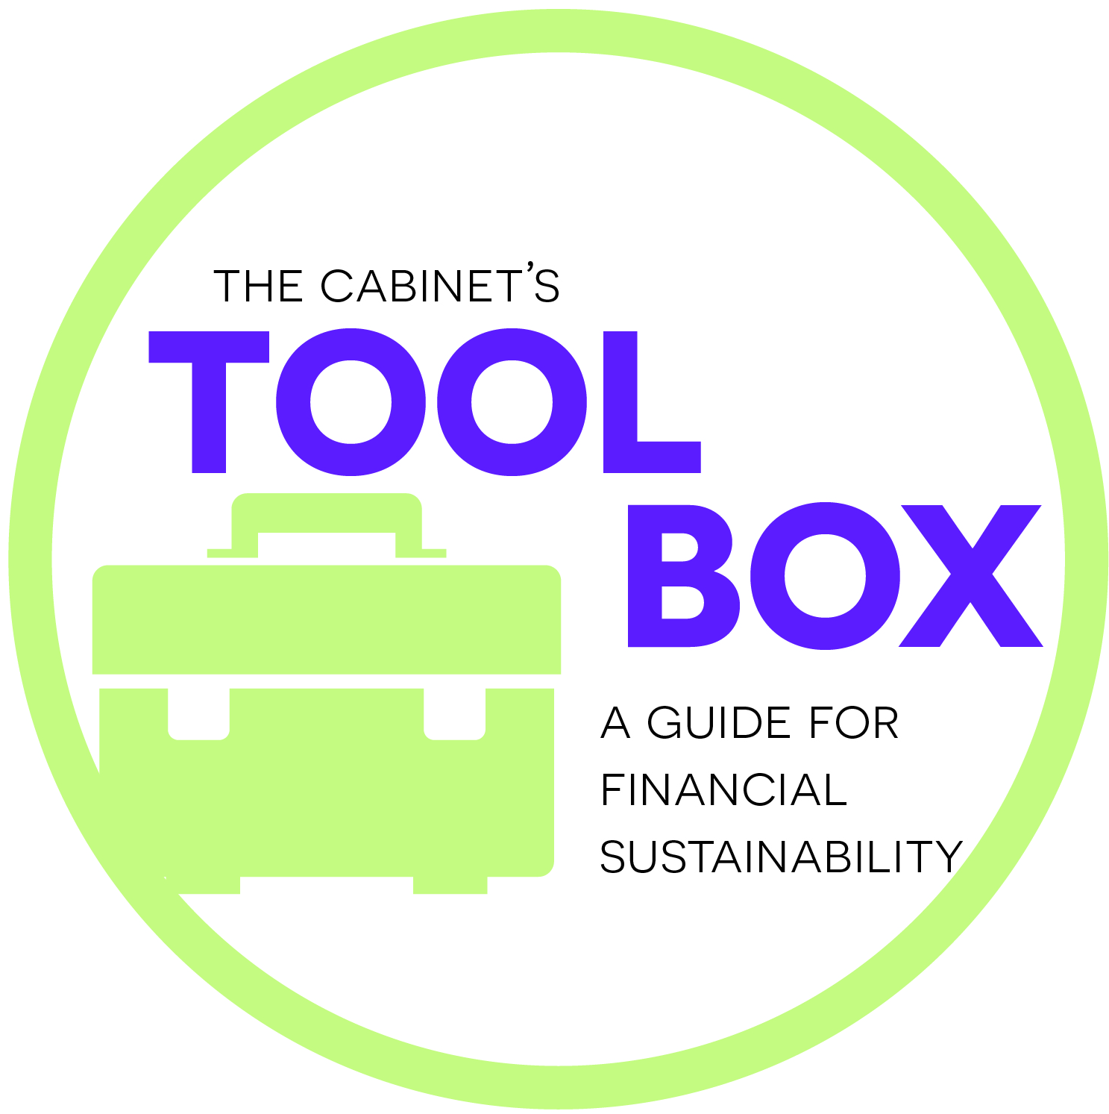
Thank You
Card Template
Dear Jackie and Jeremy,
We are so thankful for your attendance and the donation you provided at this year’s Holiday Brunch. It was great to meet you and learn about your experiences as teachers in the Peace Corps. I hope you had a wonderful time and that this is the first of many chances we have to join together. We’d love to use your travel and education expertise in the future at Yellow Tree Academy.
We set a goal at $5,000 for the brunch, and because of you and our amazing support team, we shattered that and hit $7,100 for our new Special Education Therapy Services Room. This would not be possible without our amazing team of community members.
I’m excited you’ve joined our close-knit crew and look forward to seeing you again. Please feel free to attend our Open House on August 25^{th,} so you can see the results of your support up close and get to know the staff.
Thank you again for your generosity!
Sincerely,
Sign here*

Charlie Carrick
Chairperson, Yellow Tree Academy Fund Development

*If possible, handwrite all!

