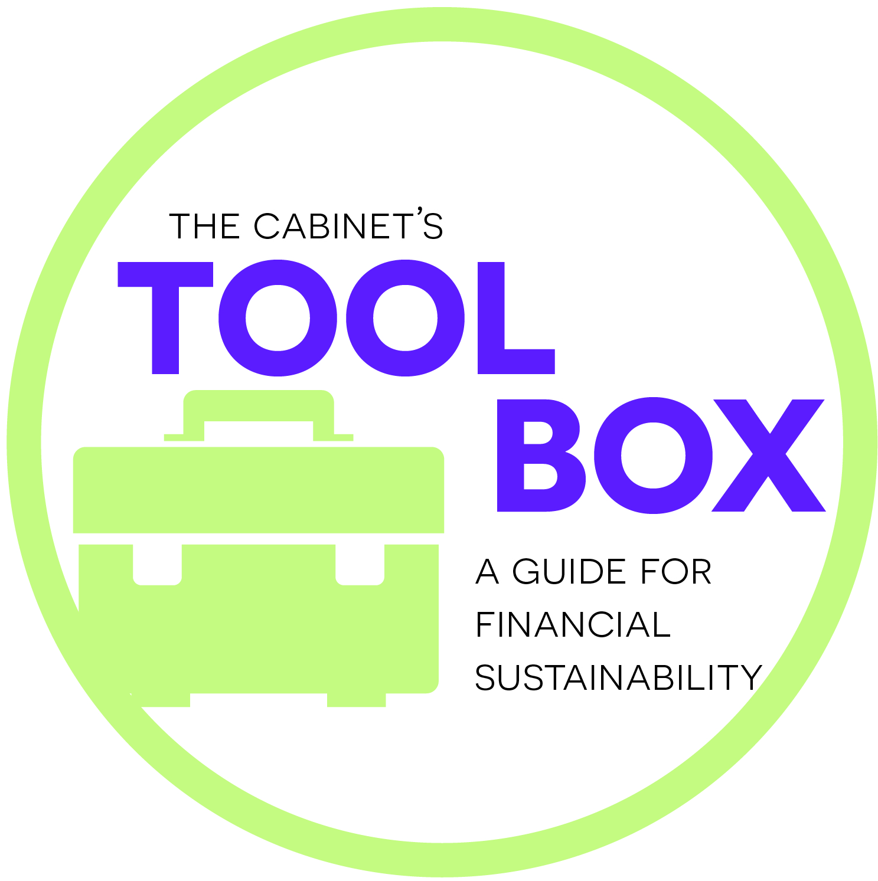
Ellie Hill
4560 S. Woodberry Road
Carey, KS 63029

Dear Ms. Hill,
I hope this letter finds you well and that you have just a moment of time to read. I am writing on behalf of the Carsen County Preschool Alliance, which provides education for over 800 young children and families in your community each year. Together, 12 different centers improve our county’s future by giving children a healthy, high quality start in life through programs that promote literacy, character-building, and extensive education for parents and siblings too. We aim to reduce problems and costs for the community down the line by intervening early, so all of Carsen’s kids start Kindergarten prepared to succeed!
In 2015, children from CCPA centers scored 5% higher than the state average on Kindergarten readiness and 2nd grade achievement, regardless of district. We all know the key to this success is amazing staff members who dedicate one-on-one time to families and work many tough hours. CCPA employs over 300 people from our area in various fields, so chances are good you know someone associated with our work! We are proud to make a difference in this great region, but cannot do it without the support of the whole community behind us.
If you can be part of our campaign for 2016, we will be incredibly appreciative! All donations this year will benefit the Reading Rockets Program which brings books and literacy supplies to our centers, or the Marshall Brennan Scholarship Fund which assists qualified families with tuition. Please consider becoming a supporter of these projects, so we can tell the rest of the state that Carsen County is united in helping our next generation!
Sincerely,
Becca Jackson

Executive Director
Carsen County Preschool Alliance
____________________________________________________________________________________
I would like to support the Carsen County Preschool Alliance with a generous gift enclosed for 2016.
___ $100 ___ $75 ___$50 ___$25___other
If you prefer, donate online now: ccpacares.org

Name_______________________________________________________________________________
Address_____________________________________________________________________________
Phone__________________________ email_______________________________________________

