Event Task List
- Venue
  - Cost
    - Contract
    - Deposit
    - Payment or cancellation deadlines
  - Size limit
  - Parking
  - Times available
  - Food storage or prep abilities
  - Restrooms
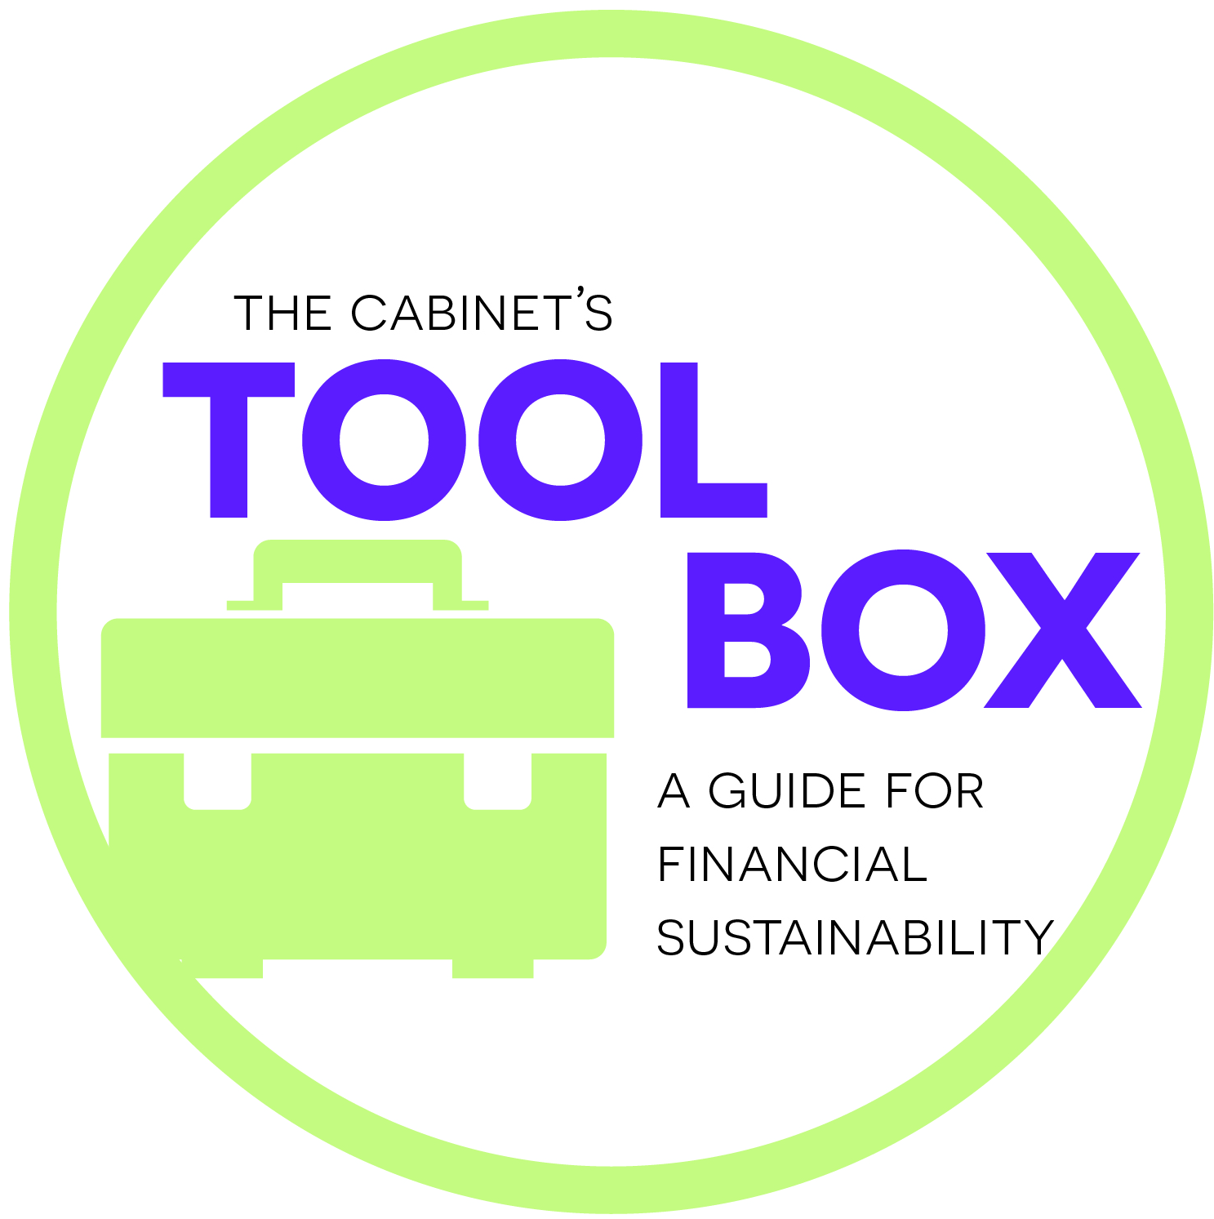
- Catering
  - Cost
    - Contract
    - Payment deadlines
    - Minimum spending requirement?
  - Final count deadline
  - Sample menu
    - Special diet options (kids, vegetarian, allergies)
  - Timing
  - Permit for alcohol
- Personnel
  - Paid staff
    - Overtime or regular work hours
  - Volunteers
    - Recruitment
    - Instructions
    - Thank you gifts
  - Exhaustive map of every job from beginning to end and who will fill it
    - Extra floating staff for absences or emergencies
  - Nametags
- Set-up and Clean-up
  - Timing
  - Supplies
    - Storage before and after
  - What is provided?
- Decorations
  - Prep time
  - Transport
  - Set up
  - Reuse?
  - Storage before and after
- Sponsorship
  - Promotion
  - Asking timeline
  - Menu of donor levels
  - Management of records
- Registration or ticket sales
  - RSVP
  - Deadlines
  - Recordkeeping
  - Refund policy
  - Information packet
  - Money exchange
- Handling money at event
- Security
  - Crowd control
  - Emergency response/medical
  - Traffic
  - Liability
- Children’s activities
  - Supplies
  - Supervision
  - Age appropriate
- Signs for sponsors
  - Logo and design
  - Costs
  - Printing
  - Space or location
  - Set-up
- Technology
  - Music
  - Projector
  - Microphone
  - Photographer
  - Tested
  - Set up
  - Back-up plan for problems
- Guest speakers or emcee
  - Cost
    - Contract
    - Travel and transportation
    - Housing
- Agenda
- Weather cancellation plan
- Promotion
  - Website
  - Print media
  - TV/Radio
  - Social Media
- Tracking info
  - Chart of tasks
  - Timeline of completion
  - Financial recording

