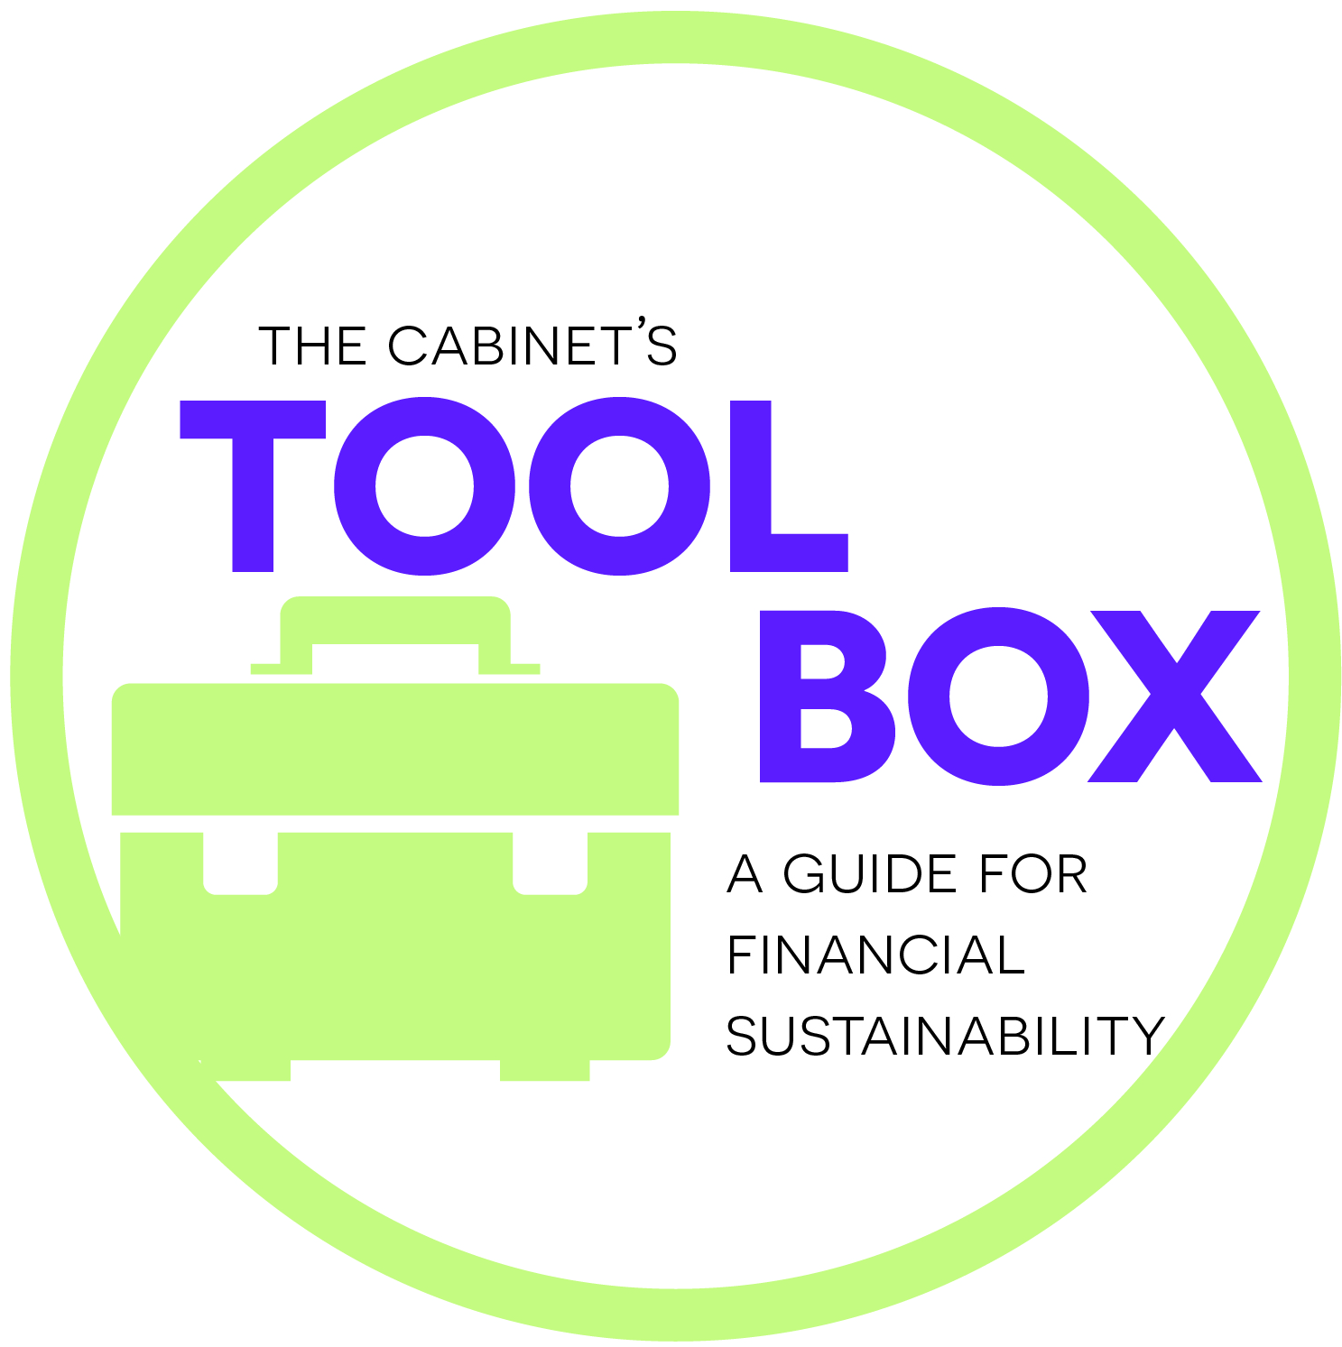
Contact Plan Template

Name | Individual or Business? | Who provided name? | Who will contact? | Method of contact? | What will be asked? | By what date? | Response – yes or no? | If yes, list donation | If no, can we ask again later?
Alex Martin | Martin Honda | Erin K. | Lisa B. | Email, call | Cash donation or use of parking lot for car seat safety day | June 15 | Yes | 1,000 cash AND use of parking lot.

